Lab 05
Name: GHULAM MUSTAFA
CMS-ID: 023-22-0099

Q. 01: Write an assembly language program that asks the user to input a character and checks if the entered character is “A” (without quotes). If the entered character is “A” (without quotes), the program should display a message, like, “The entered character is A”, as shown below


Ans: Code Solution:
.model small
.stack 100h
.data
str db "Enter the character: $"
STR1 db "The entered character is A$"
.code
main proc
mov ax, @data
mov ds, ax

; Display the message
mov ah, 9 ; acumulator register :-> output: 9
lea dx, str ; print str uisng lea method
int 21h
; take input
mov ah, 1
int 21h
mov bl, al

; print next line
mov dl, 10
int 21h

;mov bx, 65
cmp bl, 65 ; subtract the cx from bx but not update bx
; check the zero flag
JZ BLOCK1
JNE exit

; introduce blocks
BLOCK1:
MOV AH, 9
LEA DX, STR1
int 21h
jmp exit

exit:
mov ah, 4CH
int 21h
main endp
end main

Result/Output:
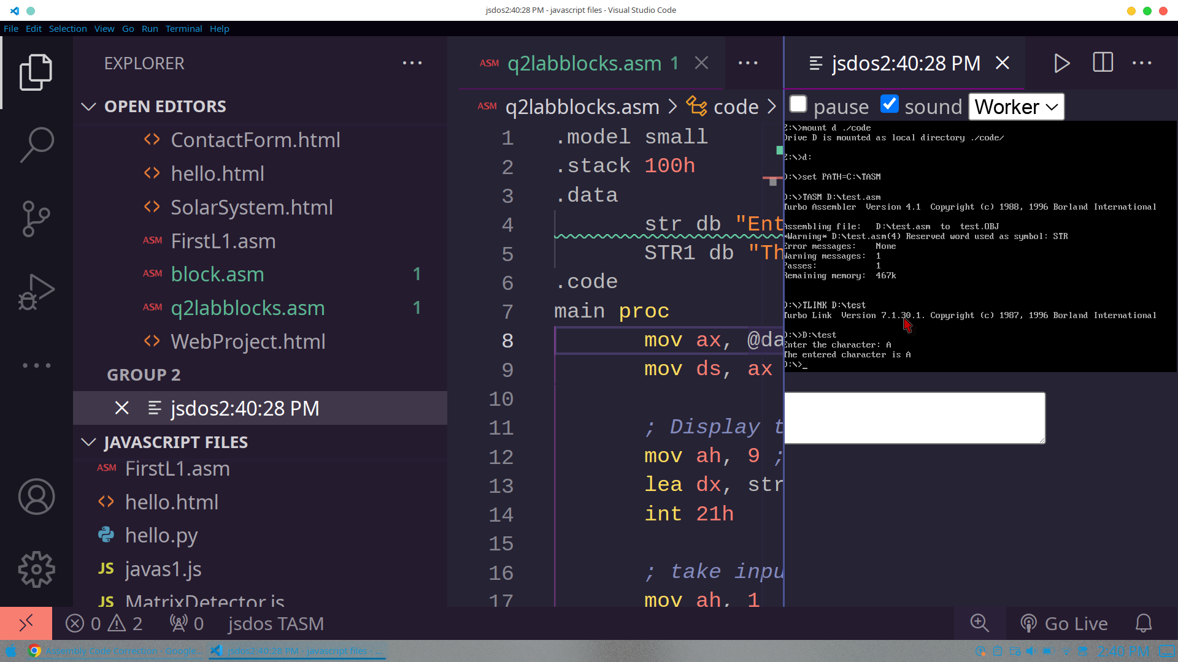

Q.02: Write an assembly language program that asks the user to input a character and checks if the entered character is NOT (equal to) “A” (without quotes). If the entered character is NOT (equal to) “A” (without quotes), the program should display a message, like, “The entered character is not A”, as shown below:


Ans: Code Solution:
.model small
.stack 100h
.data
str db "Enter the character: $"
STR1 db "The entered character is not A$"
.code
main proc
mov ax, @data
mov ds, ax

; Display the message
mov ah, 9 ; acumulator register :-> output: 9
lea dx, str ; print str uisng lea method
int 21h
; take input
mov ah, 1
int 21h
mov bl, al
; print next line
mov dl, 10
int 21h
;mov bx, 65
cmp bl, 65 ; subtract the cx from bx but not update bx
; check the zero flag
JZ exit
JNE BLOCK1
; introduce blocks
BLOCK1:
MOV AH, 9
LEA DX, STR1
int 21h
jmp exit
exit:
mov ah, 4CH
int 21h
main endp
end main
Output/Result:
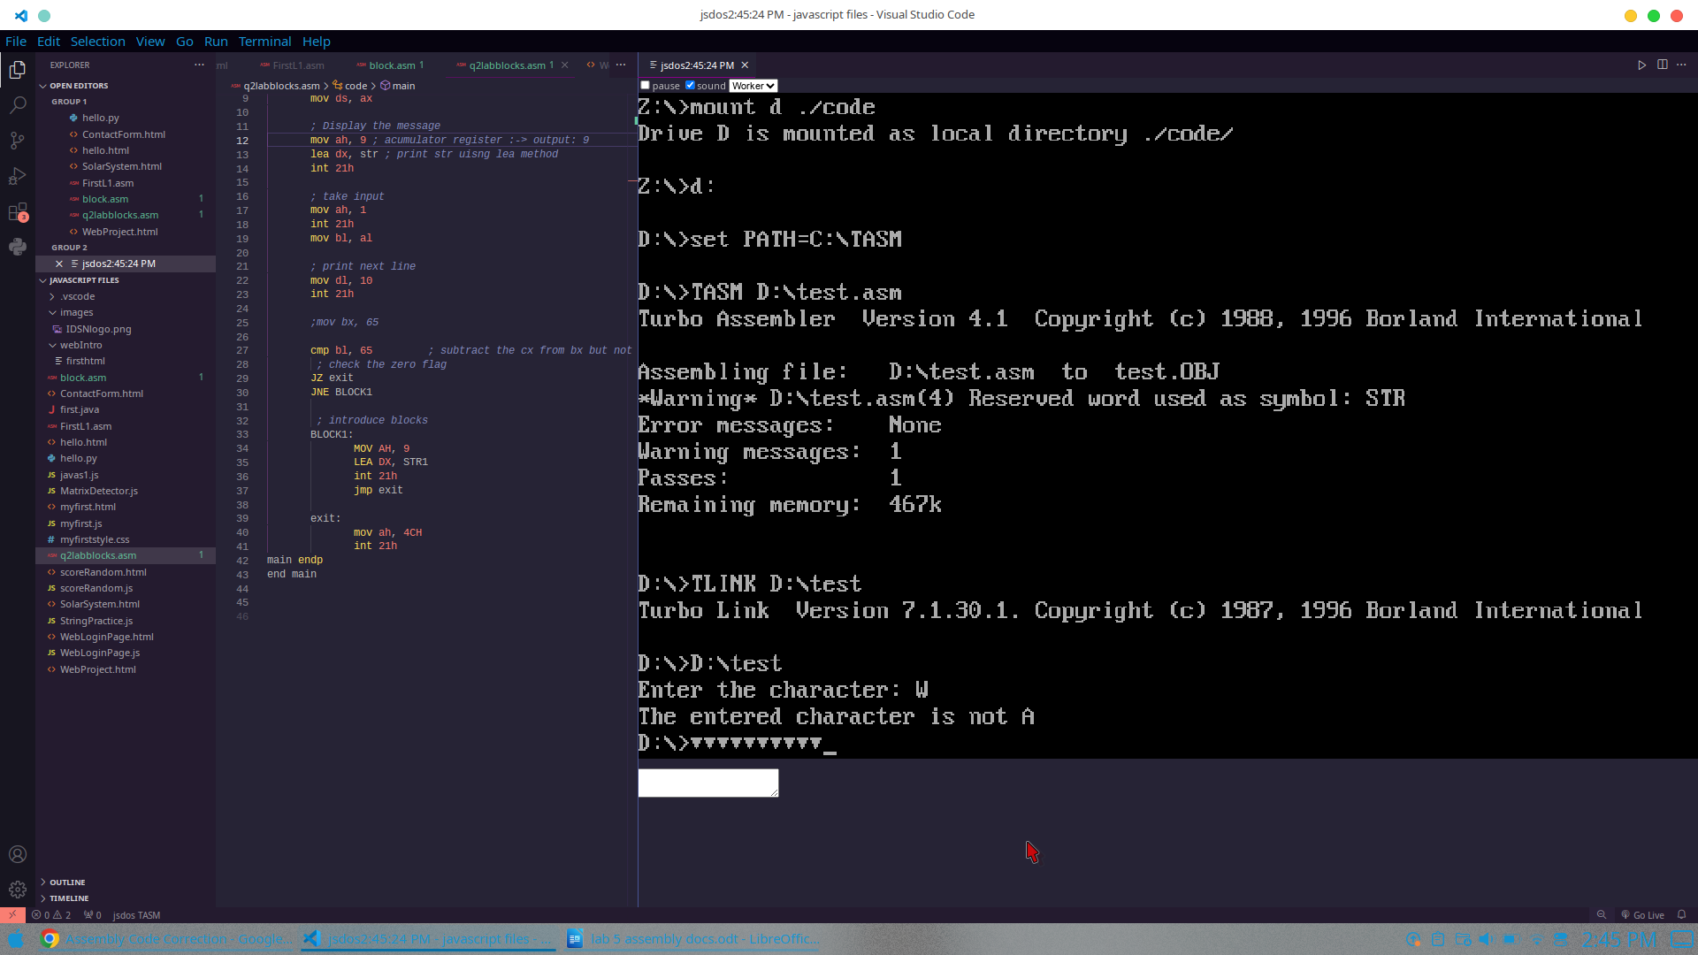

Q.O3: Now, combine the first two programs and check if the entered character is “A” or not and display a message accordingly, as shown below:
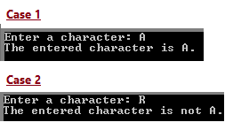

.model small
.stack 100h
.data
str db "Enter the character: $"
str1 db "The entered character is A$"
str2 db "The entered character is not A$"
.code
main proc
mov ax, @data
mov ds, ax

; Display the message
mov ah, 9 ; acumulator register :-> output: 9
lea dx, str ; print str uisng lea method
int 21h
; take input
mov ah, 1
int 21h
mov bl, al

; print next line
mov dl, 10
int 21h

;mov bx, 65
cmp bl, 65 ; subtract the cx from bx but not update bx
; check the zero flag
JZ BLOCK1
JNE BLOCK2

; introduce blocks
BLOCK1:
MOV AH, 9
LEA DX, STR1
int 21h
jmp exit

BLOCK2:
mov ah, 9
lea dx, str2
int 21h
jmp exit

exit:
mov ah, 4CH
int 21h
main endp
end main

Output/Result:
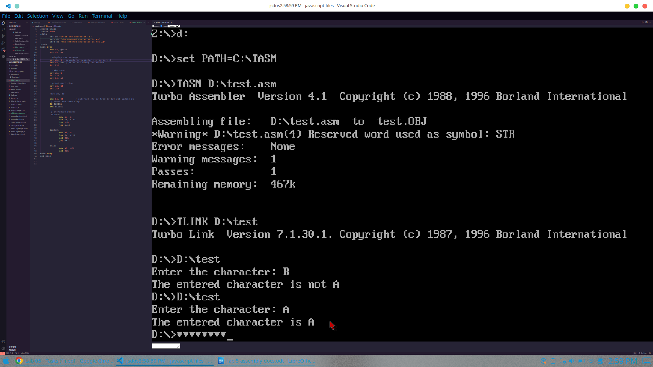

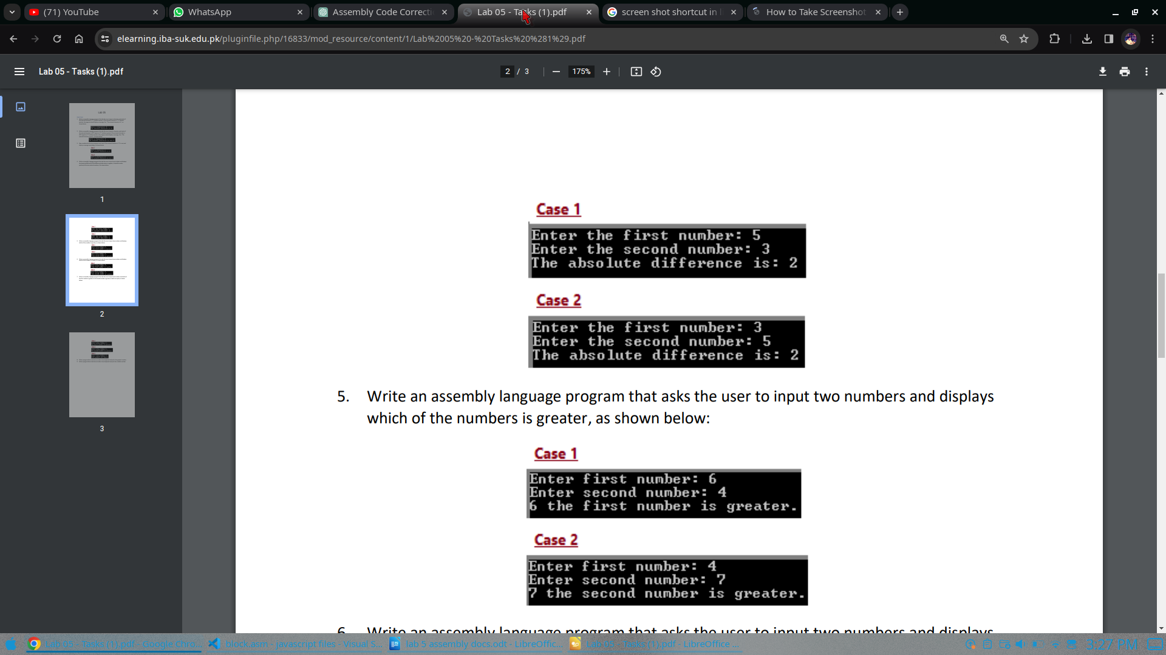
Q. 04: Write an assembly language program that asks the user to input two numbers and displays the absolute difference (if the difference/subtraction is negative, it should be made positive) of the two entered numbers, like shown below

Code Solution:

.model small
.stack 100H
.data
num1 db ?
num2 db ?
msg1 db "Enter the first number: $"
msg2 db "Enter the second number: $"
msg3 db "The Absolute Difference is: $"

.code
MAIN proc
mov ax, @data
mov ds, ax

mov DX, OFFSET msg1
mov ah, 9 ; carry or display output
int 21H
;take input number 1
mov ah, 1
int 21h
mov num1, al
;mov bl, num1

; next line
mov dl, 10
mov ah, 2
int 21h

mov dl, 13
mov ah, 2
int 21h

; print message no: 1
mov dx, OFFSET msg2
mov ah, 9
int 21h
;take input no: 2
mov ah, 1
int 21h
mov num2, al
;mov cl, num2

; print next line
mov dl, 10
mov ah, 2
int 21h

mov dl, 13
mov ah, 2
int 21h

; subtraction
mov bl, num1
sub bl, num2
; compare result of subtr:
cmp bl, 0
jge ifnonnegative
neg bl; if negative then make positive
ifnonnegative:
; print message
mov dx, OFFSET msg1
mov ah, 9
int 21H

add bl, 48 ; for converting into ascii
mov ah, 2
mov dl, bl
int 21h
;exit program
mov ah, 4CH
int 21h

MAIN ENDP
END MAIN

Output/Result:
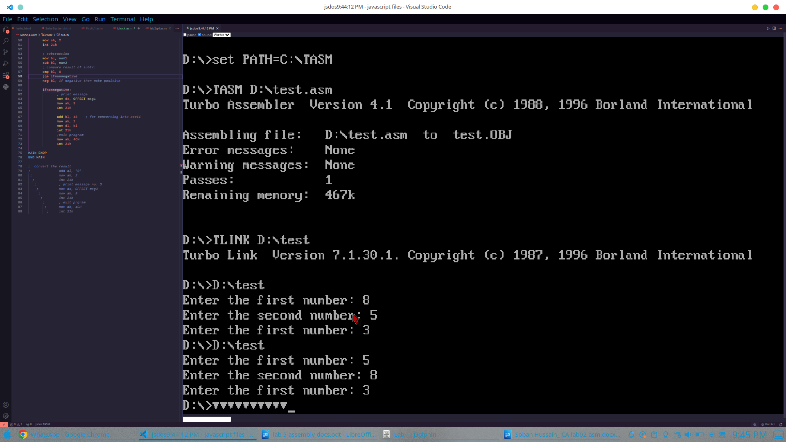

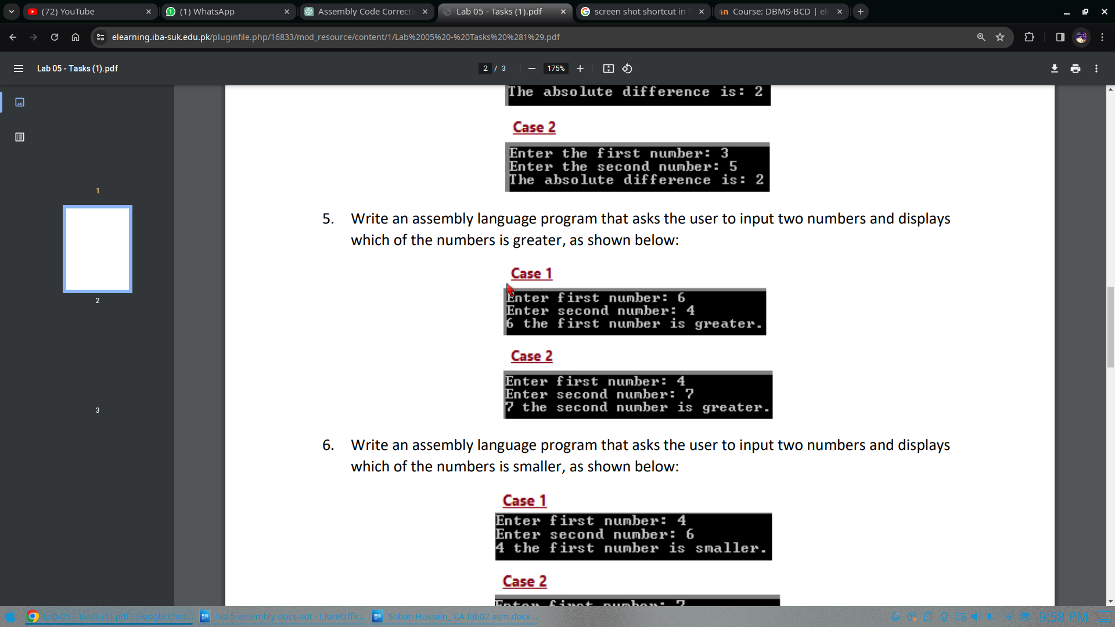
Q. 05: Write an assembly language program that asks the user to input two numbers and displays which of the numbers is greater, as shown below:

Ans: Code Solution:

.model small
.stack 100H
.data
num1 DB ?
num2 DB ?
msg1 db "Enter the first number: $"
msg2 db "Enter the second number: $"
msg3 db "first number is greater: $"
msg4 db "second number is greater: $"

.code
MAIN proc
mov ax, @data
mov ds, ax

mov DX, OFFSET msg1
mov ah, 9 ; carry or display output
int 21H

mov ah, 1
int 21h
mov num1, al
;mov bl, num1
; next line
mov dl, 10
mov ah, 2
int 21h

mov dl, 13
mov ah, 2
int 21h

; print message no: 1
mov dx, OFFSET msg2
mov ah, 9
int 21h
;take input no: 2
mov ah, 1
int 21h
;mov cl, num2
mov num2,al
; print next line
mov dl, 10
mov ah, 2
int 21h

mov dl, 13
mov ah, 2
int 21h

mov bl,num1
cmp bl,num2
jg ifgreater
jl ifsmaller
je Exit
ifgreater:

; print message no: 3
mov dx, OFFSET msg3
mov ah, 9
int 21h

mov ah, 2
mov dl,num1
int 21h
jmp Exit

ifsmaller:

; print message no: 4
mov dx, OFFSET msg4
mov ah, 9
int 21h

mov ah,2
mov dl,num2
int 21h
jmp Exit

Exit:
; exit prgram
mov ah, 4CH
int 21h

MAIN ENDP
END MAIN

Outputs:
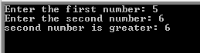
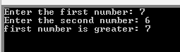

6. Write an assembly language program that asks the user to input two numbers and displays which of the numbers is smaller, as shown below:
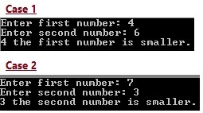
Solution:
.model small
.stack 100H
.data
num1 DB ?
num2 DB ?
msg1 db "Enter the first number: $"
msg2 db "Enter the second number: $"
msg3 db "first number is smaller: $"
msg4 db "second number is smaller: $"

.code
MAIN proc
mov ax, @data
mov ds, ax

mov DX, OFFSET msg1
mov ah, 9 ; carry or display output
int 21H
;take input number 1
mov ah, 1
int 21h
mov num1, al
;mov bl, num1
; next line
mov dl, 10
mov ah, 2
int 21h

mov dl, 13
mov ah, 2
int 21h

; print message no: 1
mov dx, OFFSET msg2
mov ah, 9
int 21h
;take input no: 2
mov ah, 1
int 21h
;mov cl, num2
mov num2,al
; print next line
mov dl, 10
mov ah, 2
int 21h

mov dl, 13
mov ah, 2
int 21h
mov bl,num1
cmp bl,num2
jg ifgreater
jl ifsmaller
je Exit
ifgreater:
; print message no: 4
mov dx, OFFSET msg4
mov ah, 9
int 21h

mov ah, 2
mov dl,num2
int 21h
jmp Exit
ifsmaller:

; print message no: 3
mov dx, OFFSET msg3
mov ah, 9
int 21h

mov ah,2
mov dl,num1
int 21h
jmp Exit

Exit:
; exit prgram
mov ah, 4CH
int 21h

MAIN ENDP
END MAIN

Outputs:

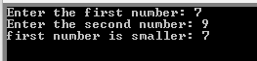
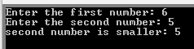

7. Write an assembly language program that asks the user to input two numbers and checks if the first number is greater or the second number is greater or both are equal, as shown below:

Solution:

.model small
.stack 100H
.data
num1 DB ?
num2 DB ?
msg1 db "Enter the first number: $"
msg2 db "Enter the second number: $"
msg3 db "first number is greater: $"
msg4 db "second number is greater: $"
msg5 db "both are equal: $"

.code
MAIN proc
mov ax, @data
mov ds, ax

mov DX, OFFSET msg1
mov ah, 9 ; carry or display output
int 21H

mov ah, 1
int 21h
mov num1, al
;mov bl, num1
; next line
mov dl, 10
mov ah, 2
int 21h

mov dl, 13
mov ah, 2
int 21h

mov dx, OFFSET msg2
mov ah, 9
int 21h
;take input no: 2
mov ah, 1
int 21h
;mov cl, num2
mov num2,al
; print next line
mov dl, 10
mov ah, 2
int 21h

mov dl, 13
mov ah, 2
int 21h

mov bl,num1
cmp bl,num2

jg ifgreater
jl ifsmaller
je ifequal

ifgreater:

; print message no: 3
mov dx, OFFSET msg3
mov ah, 9
int 21h

mov ah, 2
mov dl,num1
int 21h
jmp Exit
ifsmaller:

; print message no: 4
mov dx, OFFSET msg4
mov ah, 9
int 21h

mov ah,2
mov dl,num2
int 21h
jmp Exit

ifequal:
; print message no: 5
mov dx, OFFSET msg5
mov ah, 9
int 21h

mov ah,2
mov dl,num2
int 21h
jmp Exit

Exit:
; exit prgram
mov ah, 4CH
int 21h

MAIN ENDP
END MAIN

Outputs:

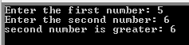
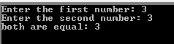
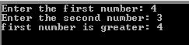

- Write a program that reads three numbers from keyboard and prints the greatest number.
Solution:

.model small
.stack 100H
.data
num1 DB ?
num2 DB ?
num3 DB ?
msg1 db "Enter the first number: $"
msg2 db "Enter the second number: $"
msg3 db "greater number is: $"

.code
MAIN proc
mov ax, @data
mov ds, ax

mov DX, OFFSET msg1
mov ah, 9 ; carry or display output
int 21H
;take input number 1
mov ah, 1
int 21h
mov num1, al
;mov bl, num1
; next line
mov dl, 10
mov ah, 2
int 21h

mov dl, 13
mov ah, 2
int 21h

mov dx, OFFSET msg2
mov ah, 9
int 21h

mov ah, 1
int 21h
;mov cl, num2
mov num2,al

mov dl, 10
mov ah, 2
int 21h

mov dl, 13
mov ah, 2
int 21h

mov dx, OFFSET msg2
mov ah, 9
int 21h

mov ah, 1
int 21h
mov num3,al
; print next line
mov dl, 10
mov ah, 2
int 21h

mov dl, 13
mov ah, 2
int 21h
mov bl,num1
mov cl,num2

cmp bl,num2
jg iffirst
jl ifsecond
je Exit
iffirst:
cmp bl,num3
jg block1
jl block01
je equal01

block1:
mov dx, OFFSET msg3
mov ah, 9
int 21h

mov ah, 2
mov dl,num1
int 21h
jmp Exit
block01:
mov dx, OFFSET msg3
mov ah, 9
int 21h

mov ah,2
mov dl,num3
int 21h
jmp Exit
equal01:
mov dx, OFFSET msg3
mov ah, 9
int 21h

mov ah,2
mov dl,num2
int 21h
jmp Exit

ifsecond:

cmp cl,num3
jg block2
jl block02
je equal02
block2:
mov dx, OFFSET msg3
mov ah, 9
int 21h

mov ah,2
mov dl,num3
int 21h
jmp Exit
block02:
mov dx, OFFSET msg3
mov ah, 9
int 21h

mov ah,2
mov dl,num3
int 21h
jmp Exit
equal02:
mov dx, OFFSET msg3
mov ah, 9
int 21h

mov ah,2
mov dl,num2
int 21h
jmp Exit

Exit:
; exit prgram
mov ah, 4CH
int 21h

MAIN ENDP
END MAIN

Outputs:

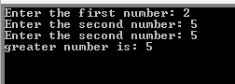
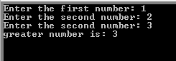
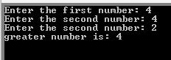

- Write a program that reads three numbers from keyboard and print the smallest number.
Solution:

.model small
.stack 100H
.data
num1 DB ?
num2 DB ?
num3 DB ?
msg1 db "Enter the first number: $"
msg2 db "Enter the second number: $"
msg3 db "all is equal: $"
msg4 db "smaller number is: $"

.code
MAIN proc
mov ax, @data
mov ds, ax

mov DX, OFFSET msg1
mov ah, 9 ; carry or display output
int 21H

mov ah, 1
int 21h
mov num1, al

mov dl, 10
mov ah, 2
int 21h

mov dl, 13
mov ah, 2
int 21h

mov dx, OFFSET msg2
mov ah, 9
int 21h

mov ah, 1
int 21h

mov num2,al

mov dl, 10
mov ah, 2
int 21h

mov dl, 13
mov ah, 2
int 21h

mov dx, OFFSET msg2
mov ah, 9
int 21h

mov ah, 1
int 21h
mov num3,al

mov dl, 10
mov ah, 2
int 21h

mov dl, 13
mov ah, 2
int 21h
mov bl,num1
mov cl,num2

cmp bl,num2
jg iffirst
jl ifsecond
je ifthird
iffirst:
cmp cl,num3
jg block1
jl block01
je equal01

block1:

mov dx, OFFSET msg4
mov ah, 9
int 21h

mov ah, 2
mov dl,num3
int 21h
jmp Exit
block01:
mov dx, OFFSET msg4
mov ah, 9
int 21h

mov ah,2
mov dl,num2
int 21h
jmp Exit

equal01:
mov dx, OFFSET msg4
mov ah, 9
int 21h

mov ah,2
mov dl,num2
int 21h
jmp Exit

ifsecond:

cmp bl,num3
jg block2
jl block02
je equal02

block2:
mov dx, OFFSET msg4
mov ah, 9
int 21h

mov ah,2
mov dl,num3
int 21h
jmp Exit

block02:
mov dx, OFFSET msg4
mov ah, 9
int 21h

mov ah,2
mov dl,num1
int 21h
jmp Exit

equal02:

mov dx, OFFSET msg4
mov ah, 9
int 21h

mov ah,2
mov dl,num1
int 21h
jmp Exit

ifthird:

cmp cl,num3
jg block3
jl block03
je equal03

block3:

mov dx, OFFSET msg4
mov ah, 9
int 21h

mov ah, 2
mov dl,num3
int 21h
jmp Exit

block03:
mov dx, OFFSET msg4
mov ah, 9
int 21h

mov ah,2
mov dl,num2
int 21h
jmp Exit

equal03:
mov dx, OFFSET msg3
mov ah, 9
int 21h

mov ah,2
mov dl,num1
int 21h
jmp Exit

Exit:
; exit prgram
mov ah, 4CH
int 21h

MAIN ENDP
END MAIN
Outputs:

